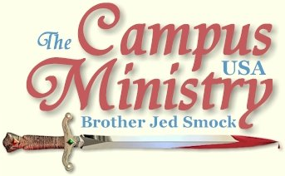
brojed.org
brojed@aol.com
573-999-0347
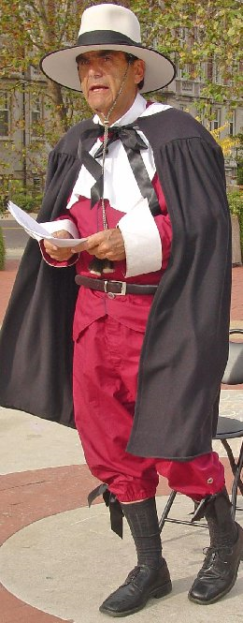
Note From Sis. Cindy:
As I write this, Bro. Jed is leaving to preach today at the University of Kansas. It will be his last preach before Thanksgiving Break. We are having three Vietnamese graduate students for Thanksgiving Dinner. They just came to America in September. Pray for them. Bro Cope will be with us also.
Priscilla has posted Bro. Jed's William Bradford (pilgrim) presentation on Youtube in three parts. The final part is yet to come. Check it out at http://www.youtube.com/watch?v=2dkLKwy4M7Q
Also take some time over the holiday to check out our new web site! There are lots of new pictures and our dvds are available for download.
We are very thankful for all of you. Have a blessed Thanksgiving with your family!

November 9, 2009,

Today I flew home from Cortez, CO, where I spoke in a church on Sunday. The congregation gave me the largest offering I have ever received for a Sunday meeting. And I have spoken in many much larger churches. This generous church had about 125 in attendance in each service. In the morning I preached my signature message, “Who Will Rise Up?” And in the evening my message was entitled, “The Reconciliation,” which is another word for the Atonement.

DIVERSITY AND TESTICLES

University of Missouri, November 10, 2009

"Change the face of Men’s Health, grow a mustache for prostate and testicle cancer," cried a bunch of boys who were promoting their cause on Speakers' Circle.

Cindy made fun of their cheap handmade signs, while she wore a sandwich board which read "Jesus Saves from Hell." I warned them that habitual masturbation increases their likelihood of getting prostate cancer, knowing that they have been told just the opposite. This was going on as a few students were passing and a few others were sitting on the steps of Speakers’ Circle. Later, Cindy warned the horny devils that it would be better for them to cutoff their testicles then to continue in fornication and their whole body be cast into Hell-Fire.

As the traffic picked up, I cried "America's chickens are coming home to roost! Decades ago, America hatched the egg of promoting diversity over freedom as a basic American principle; and we suffered the consequences when Major Moslem massacred his fellow countrymen at Ft. Hood last week."

I paraphrased General of the Army Casey, who said over the weekend, “Our diversity, not only in our Army, but in our country, is strength. And as horrific as this tragedy was, if our diversity becomes a casualty, I think that’s worse.”

I commanded that we get rid of Casey and find another Jackson, Grant, Sherman or Patton. Someone is needed who knows how to fight a war and not wring his hands over the loss of diversity more than the lives of the loyal soldiers whom he commands. We do not need generals wringing their hands at all; we need fighting generals, certainly not another Colin Powell, who is more of a diplomat then a warrior.

I reminded the students that President Roosevelt established internment camps for American Japanese during WW II; and President Andrew Jackson forcibly removed the Indians from Georgia during his presidential administration. We at least need to stop the emigration of Moslems into America. I suggested tongue in cheek that perhaps we could compromise and let the homosexuals in the Army and root out the Moslems. Actually, none of this got as much reaction from the students as I hoped. I wanted to have a serious discussion on diversity and the terrorist attack on Ft Hood. However, later, while Cindy was preaching, a student newspaper reporter asked me about these quotes.

It demonstrates the weakness of American males that a group of young men are raising money for prostate and testicular cancer days after the Ft. Hood massacre, when they should be stirred to fight for their country. Apparently these boys and other students have either lost their testicles or never had any from the beginning. No one in my audience would condemn this traitor; some even suggested that he was not a Moslem; and a few claimed that he was a Christian!???? None of them indicated they were disturbed by the slaughter of our soldiers.

Even though it was about 60 and mostly cloudy and breezy, we gathered a crowd that remained consistently around 100 for most of the afternoon. We preached until 5:30.

Cindy was distraught over the many girls who admitted publicly and privately that they were bisexual. Many more women claimed bisexuality than men. When Cindy mentioned this to me at home, I agreed that it does seem that more girls of late are claiming to be bisexual. Martha said she suspected that some of the girls were just saying that to impress the boys, who think that makes a girl "hot."

Cindy was encouraged that she was able to give a good witness to an Indian girl who had rejected Hinduism and was working on a PhD. She asked Cindy, "Can one be a good person without believing in Jesus?"

Cindy replied. "That is not the issue. You cannot be forgiven of your sins without the sufferings of Christ and believing in him. You need to ask, 'Why did Jesus suffer on the Cross?'"

THE DIVERSITY OF MISSOURI

University of Missouri, November 11, 2009,

The hacky sack man was performing in Speakers’ Circle when I arrived. He was kind enough to yield to me at the 12:50 break.

I acknowledged that it was Veteran’s Day; and we needed to be thankful for those who have fought to protect our freedoms. I read General Casey’s quote promoting diversity over the lives of his soldiers. I suggested that the name of Mizzou be changed to the Diversity of Missouri. Diversity emphasizes differences and division over a unified body of Knowledge and Truth.

I took out my Koran and read verses which demonstrate that the book is an attack on Christianity; and it advocated jihad against Christians and Jews. But students demonstrated no concern over General Casey or the threat of the diabolical religion of the false prophet, or the massacre at Ft. Hood. They preferred to talk about sex; but I tried to avoid this issue and finally directed the conversation to the doctrine of holiness and the true nature of love.

A professor asked me to yield to his group, which was urging the university to drop coal as an energy resource. He spent 20 minutes lecturing on the dangers of coal to the environment and human health. I did not buy any of this. But he had 20 students very concerned. I was disturbed that they had no concerns over the real threats to this country, like terrorist attacks and America’s moral slide. To the credit of a few students they were passing out Christmas cards for the students to write notes and send to the overseas troops for Christmas.

I started speaking again at 2:30; but I never regained the students’ attention as well as I anticipated that I would have on a sunny day in the low sixties.

One fellow, who flunked out of school and was now a bartender, kept asking vulgar questions of a sexual nature.

“Who be unto him who gives his neighbor strong drink,” I warned.

The bartender was hand in hand kissing a girl and talking about how much she enjoyed being sodomized. The stupid woman giggled. I sensed that this man was very evil and a pervert to the core. When I realized this, I refused to answer his questions. After the girl left, he came on to two other girls. I thought that this guy could be a Ted Bundy in the making.

By 3:30 only about 10 people were listening. Had my energy level been up to par I could probably have gathered another sizable crowd; but it can take a lot of work to build up a crowd and I was not up to it today. Therefore, I stopped speaking at 3:55.

GRACE IS NOT A LICENSE TO SIN

University of Missouri, November 12, 2009

Rick, a local businessman, was preaching in Speakers’ Circle when I arrived. Rick preaches sometimes once a week at Mizzou. Usually, he does not speak for much more than an hour. I do not know what time he started; but he preached until about 1:30. His message was on grace. But his presentation of grace is a license to sin. He said, we cannot keep nor are we expected to keep the Sermon on the Mount. Yet he emphasized that God was not a hard taskmaster. I regretted that I had left without my pen and notebook. I would have liked to have recorded some of his quotes. Whenever I have heard Rick, he gets few negative interruptions; few ask questions or make comments and there is very little heckling.

When I took the center of the circle, I asked, “Brother Rick if God commands us to do what we are not able to do and threatens us with Hell for not obeying his commands, how is he not a hard taskmaster?”

In reply he repeatedly said, “I know of no one who loves his neighbor as himself.”

I pointed out that Jesus finished the Sermon on the Mount by saying only those who “do the will of my Father shall enter into the Kingdom. And, “Therefore whosoever heareth these sayings of mine, and doeth them I will liken unto a wise man who built his house on a rock.”

Jesus fully expected men to build their house upon Him and obedience to his teachings or their house will be in for a great fall.

We went over a number of Scriptures. I read one that I have not brought out in my past encounters with Rick, which is a prayer of Paul, “The Lord make you to increase and abound in love one toward another, and toward all men, even as we do toward you: To the end he may stablish your hearts unblameable in holiness before God, even our Father, at the coming of our Lord Jesus Christ with all his saints.”

When I bring out Scriptures such as this, typically Rick falls back on Romans 7 or 1 John 1:8.

Eventually, Rick became involved in a discussion with a student who asked Rick about the sacraments as a means of grace. Rick had claimed that the blood of Jesus is the only means of grace.

So I started preaching from the second greatest commandment to the students gathered in the Circle, “Thou shalt love thy neighbor as thyself.”

I told the students, “I love you as I love myself. That is why I am on campus five hours a day, five days a week for the past thirty-five years.” I love you so much that one of my daughters said to me once, “Dad, it seems like you love the students more than us.’”

I continued, “Rick claims that if you have more than your neighbor that is an indication that you love yourself more than him. However, it may not be the best thing for your neighbor or for society in general for you to give everything you have to your neighbor. Living honestly and industriously and being a good example for your neighbor may be more loving than turning over to him all your possessions.”

My message on love may have touched some hearts for two students announced that they love me. And they seemed sincere.

I could tell that one man who was standing in front of me was fixed on my message. After an hour he came up and said, “Do you remember me from SEMO (Southeast Missouri State University)? I had 666 written on my forehead. I was atheist. I am now ashamed of that. Now I am a Deist. Is that OK?” I replied, “That is a step in the right direction.”

He said, “I agree with you on capitalism. Keep up what you are doing.” He shook my hand and walked away.

It was a very good afternoon; one young man who was better dressed than most in my audience claimed that he was once going to become a preacher, but he got involved in magic. He asked, “Why did Jesus have to shed his blood for men’s sins to be forgiven?” I expounded on the atonement. He said he understood my answer. Then he asked about the animal sacrifices. He also indicated he understood my answer on why they were required.

In the evening I dressed as the Pilgrim father, Governor William Bradford. I read from his History of Plymouth Plantation at a home school gathering.
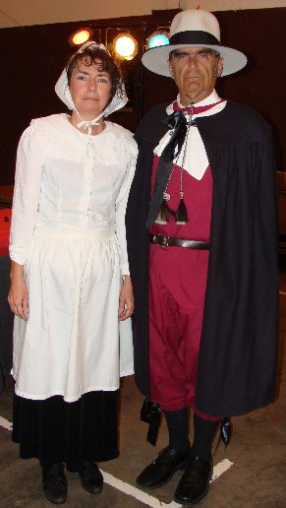
Governor and Mrs. William Bradford


Martha and Priscilla, along with their friend Shelby Butterworth, dressed as American Indians for the Thanksgiving Event

Pilgrims and Indians

"Me Wild Injun," Iris (our granddaughter)

Gov. and Mrs. William Bradford
Speak at Mizzou

University of Missouri, November 13, 2009

Cindy and I decided to take the Governor and Mrs. William Bradford show to the campus. As soon as I arrived several students wanted to get their picture taken with me. I read excerpts from Bradford’s History of Plymouth Colony.
Bradford reflects when the Pilgrims land in the new world, “But here I cannot but make a pause, and stand half amazed at this poor people's present condition; and so I think will the reader, too, when he considers it well. Having thus passed the vast ocean, and that sea of troubles before while they were making their preparations, they now had no friends to welcome them, nor inns to entertain and refresh their weatherbeaten bodies, nor houses—much less towns—to repair to.
The savage barbarians when they met with them (as will appear) were readier to fill their sides full of arrows than otherwise! As for the season, it was winter, and those who have experienced the winters of the country know them to be sharp and severe, and subject to fierce storms, when it is dangerous to travel to known places,—much more to search an unknown coast. Besides, what could they see but a desolate wilderness, full of wild beasts and wild men; and what multitude there might be of them they knew not! For which way soever they turned their eyes (save upward to the Heavens!) they could gain little solace from any outward objects. Summer being done, all things turned upon them a weather-beaten face; and the whole country, full of woods and thickets, presented a wild and savage view.
If they looked behind them, there was the mighty ocean which they had passed, and was now a gulf separating them from all civilized parts of the world.
What, then, could now sustain them but the spirit of God, and His grace ? Ought not the children of their fathers rightly to say: Our fathers were Englishmen who came over the great ocean, and were ready to perish in this wilderness; but they cried unto the Lord, and He heard their voice, and looked on their adversity. . . . Let them therefore praise the Lord, because He is good, and His mercies endure forever. Yea, let them that have been redeemed of the Lord, show how He hath delivered them from the hand of the oppressor. When they wandered forth into the desert-wilderness, out of the way, and found no city to dwell in, both hungry and thirsty, their soul was overwhelmed in them.” Let them confess before the Lord His loving kindness, and His wonderful works before the sons of men!
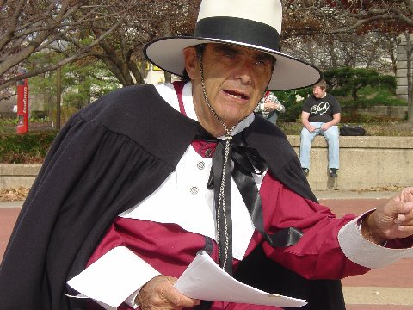
And to think none of them had health insurance either. Yet “they confessed before the Lord His loving kindness and his wonderful works before the sons of men!”
An English professor brought out his American Literature class to listen to my reading. I received my most vocal opposition when I told the story of the Pilgrims first encounter with the “savages.” Many arrows were flying and muskets were shot; but no one from either side was hurt. Bradford concludes by saying, “Thus it pleased God to vanquish their enemies, and give them deliverance; Afterwards they gave God solemn thanks and praise for their deliverance. They called the place "The First Encounter."
A student asked, “Do you believed that God was on the side of the Pilgrims.”
“Of course, the Pilgrims were on the side of God and the Indians were unbelievers, thus children of the devil.”
The student accused the Pilgrims of stealing the land from the Indians. But I rebuked him and others who chimed in: “You curse our forefathers, who cleared the wilderness and tamed the wild savage. Yet enjoy the fruit of their hard work and sacrifice.”
God promised to his people, “Ask of me, and I shall give thee the heathen for thine inheritance, and the uttermost parts of the earth for thy possession (Psalm 2:8).”
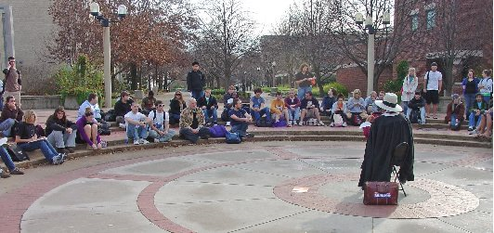
I read from the Mayflower Compact to establish the Christian foundation of our country, “In the name of God, Amen. . . Having undertaken for the glory of God, and advancement of the Christian faith, and honour of our king and country, a voyage to plant the first colony in the northern parts of Virginia, do by these presents solemnly and mutually in the presence of God, and of one another, covenant and combine ourselves into a civil body politic. . .”
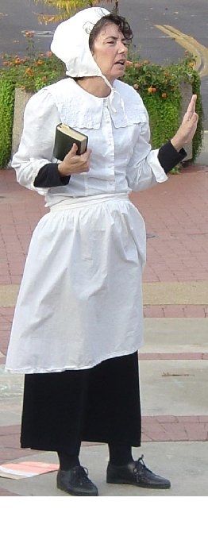
Cindy spoke on the family life of the Pilgrims which provoked discussion concerning the role of women.
In 1623 three years after their arrival in Cape Cod, Bradford concluded their failed experiment in communism. Every family was assigned a parcel of land.
Bradford writes, “The failure of this experiment of communal service, which was tried for several years, and by good and honest men proves the emptiness of the theory of Plato and other ancients, applauded by some of later times,—that the taking away of private property, and the possession of it in community, by a commonwealth, would make a state happy and flourishing; as if they were wiser than God. For in this instance, community of property (so far as it went) was found to breed much confusion and discontent, and retard much employment which would have been to the general benefit and comfort. If (it was thought) all were to share alike, and all were to do alike, then all were on an equality throughout, and one was as good as another; and so, if it did not actually abolish those very relations which God himself has set among men, it did at least greatly diminish the mutual respect that is so important should be preserved amongst them. Let none argue that this is due to human failing, rather than to this communistic plan of life in itself. I answer, seeing that all men have this failing in them, that God in His wisdom saw that another plan of life was fitter for them.”
Oh, if we would learn from the lessons of history. Communism was tried in the beginning and failed; now Obama wants us to go in that direction again.
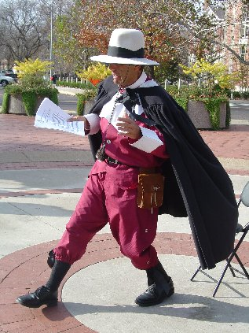

FIRING THE WORD AT THE DAWGS
University of Georgia, November 16, 2009
The free speech platform at the Tate Center was occupied for the afternoon by student groups. My host, Raymond D., and I went to the plaza of Memorial Hall. This is the location where I preached before the building of the Tate Center. But M.H. plaza has limited traffic now. Raymond seeing a lot of students around the North end of the Tate Center urged me to move to that area. I followed his leadings. Quickly, I gathered a crowd of 20.
However, within 15 minutes security told me that I had to preach at the Tate Center. I explained that the area was occupied. I talked over the phone to the woman in charge of security, who informed me that it was the only free speech area. But I went to the Campus Reservation office in Tate Center and a female in charge informed me that the Memorial Hall plaza was an alternative free speech area. I returned to Memorial Hall. Meanwhile, Raymond D. had stayed around the area North of Tate; where he was communicating quietly with a small group of students.
I started firing the Word of God at the Memorial Hall shortly after 1 PM and gathered a group of 8-10 students; however, within 20 minutes they all dispersed. After 2 PM I fired again in front of the Tate Center. I managed to gather about 6 students. There was another half dozen sitting in on the steps of the Memorial Hall, some of whom were smoking. It is advantageous to the preachers that the smokers have been driven outside. They usually provide a small audience on the worst of days. After a while the smokers moved closer; so that they could hear well.
I was able to bring the two groups together in one spot and eventually built of the crowd to a maximum of 20. Until 5 PM the crowd usually ranged from 10-12. One girl confessed to be a backslidden Christian. Two girls professed to be bisexual and one of them an atheist, whose name was Courtney. She claims she rejected Christianity because her grandparents dragged her off to church and because of her rebellion would not let her eat Christmas dinner. Two other girls professed to be Christians; but they did not like my methods or message. One of them; however, had an attitude change as the afternoon progressed. One boy, who was a converted Jew, did speak boldly on behalf of Christ. A nucleus of about eight students, including the ones I mentioned, stayed with us for most of the afternoon. We stopped firing at 5 PM.
Raymond D. spoke to the students for over 30 minutes. Raymond, who is a long time friend and supporter of my mission, is retired. Despite our small crowd, I considered the afternoon to be productive. On the way home Raymond said that he often had to hold back open laughter at some of my humor at the expense of the follies of college life.
MOSLEM CHRISTIAN ALLIANCE AGAINT AN ATHEIST
Georgia State University, November 17, 2009
I tried to preach on this campus back in the 70’s; but I got stopped by security. The SOAPA conference recently opened the campus. I was advised to contact Dr. Rebecca Stout in the Student Affairs office. She telephoned me as I came out of the parking garage. She met me at the Student University Center entrance with a copy of the campus speech policy. She asked, “Are you the Brother Jed that used to preach at Arizona State?”
When I affirmed that I was she replied, “I thought so; there could only be one Brother Jed.” She was a student at in the late 70’s and then worked in administration in the early 80’s. “So you have been doing this for 35 years. Now that is dedication,” she said.
Those were wild years at ASU where they always provided heavy campus security in the late 70’s and early 80’s. One year I preached with about ten uniform policemen encircling me and several plain clothes policemen in the crowd. This was the day after a group of angry lesbians jumped me.
She took me to the office of the Director of the Student University Center to find out what areas on campus had not been scheduled. She then escorted me to the Library Plaza where I started preaching under a light rain. Some students listened off at a distance under covering of the library. A few engaged me; but after 30 minutes, I decided to go back to the car and get my umbrella and sandwich board sign which lists damnable sins.
At the next break it was still raining. Many students read my sign as they passed by without stopping. After the break once again I returned to the car since I had forgotten my chair. I considered calling it a day; but I decided to give it one more shot. By the 2 PM break the rain stopped; so I was able to gather a crowd of up to fifty. One fellow threatened to knock me off the platform if I did not stop preaching; but I am not intimidated by students. One professing Christian objected to the negativity of my sign. Another girl reproved me for be angry. She read James 1:19: “Everyone should be quick to listen, slow to speak and slow to become angry.”
She admonished me for being angry. I replied, “I represent God; and God is angry with the wicked every day.”
Three different times the campus security approached me and informed me that I needed a permit. I informed them I did not need a permit; but I had checked in at the Student Affairs office. Thankfully, I had a copy of an email from Dr. Stout and upon presenting that the police backed off each time.
There were a number of lewd girls in the crowd whom I had to rebuke, several with tongue piercings which is a bad sign. However, one of the girls stayed to the end and seemed to be really listening.
From of a group of Christians, one girl said, “Not everyone who calls themselves Christian around here is Christian. If you are a Christian you will get angry at sin.” I praised the girl for making that point; and I told the students of the girl earlier in the day who had rebuked me for being angry.
I had interaction with a black student, who was raised a Christian but converted to Islam, about the nature of Christ. However, when an atheist was presenting his case against God, the Moslem started working with me in defending God to the atheists. He gave good answers to the atheist. At 4:30 it started raining again; so I departed. However, I noticed that the students continued talking about religion in the rain after I left.
BAITING THE STUDENTS
Georgia College and State University, November 18, 2009
“It is the right of a bystander to keep passing by if they hear something they don’t like rather than permitting themselves to be baited into responding and/or engaging in conflicts.” This sign was posted in the free speech zone in large letters by the GCSU office of Student Affairs.
GCSU is a public university with 6000 students. It “places emphasis on providing the quality, values, and virtues of a private liberal arts college, but at a lower and more reasonable cost.”
The institution has succeeded in providing the atmosphere of a small liberal arts college. It is in the small town Milledgeville which was once the capital of Georgia.
Raymond D. joined me again today. I started preaching at the center of the Quad; but within 15 minutes a female administrator with an attitude approached me carrying her sign informing me that I had to go to the end of the Quad which is the designated free speech area, where she stuck her sign in the ground. This area was out of the main flow of traffic. However, it did not hinder us from gathering a crowd of up to 70 students with the crowd usually around 60.
Obviously the SA sign was indirectly encouraging the students not to stop and listen and engage speakers in dialogue and debate. I doubt that when other than Christian preachers are on campus that the SA office bothers to display the sign. Much to my expectations and delight the sign did not accomplish its purpose.
Very quickly several very vocal professing Christians opposed us for preaching hate, being judgment and for promoting complete obedience to God which they considered to be impossible. Raymond was wearing the sandwich board sign. One boy said to us, “You are missing one sin. You need to add false teachers. You men are false prophets. No one can live without sin.” Then he ended his spiel with, “We are not to judge.”
On at least three occasions different ones said to the crowd. “Don’t listen to these men. Don’t argue with them. That is what they want. You are giving them an audience. Everyone needs to just leave.”
Each time a few left. However, the ones that left usually showed up again, including the ones exhorting everyone not to listen.
Our bait is the uncompromised word of God. Students almost always bite. But like a hooked fish, they squirm and fight not willing to be reeled into the gospel boat. The mind is naturally attracted to truth. However, the rebellious will fights the truth. The truth calls for a submission of the will to what the mind and conscience affirms to be true. These faculties know that a man ought to live unselfishly; but the will clings desperately to its love for the dark and turbulent sea of self-indulgence.
There were a number of alleged Christians desperately pleading for sin and opposing righteousness with all of their strength. Many were frantically turning the pages of the Bible to find verses to excuse their sin. I forget how many times I had to address Rom 3:10 and 23, Romans 7 and 1 John 1:8.
One boy with an open Bible fell to his knees defending the born sinful doctrine. He read Psalm 51:5 from the NIV, “Surely I was sinful at birth, sinful from the time my mother conceived me.”
The translation of this verse is one of many reasons I do not preach from the NIV with its general promotion of an inherent sin nature. The KJV puts a different slant on what David is saying. But suppose the NIV translation is accurate then it would be an example of hyperbole. To suggest that David is teaching the doctrine of an inherited sinful nature with its companion doctrine of inability, in a penitent psalm where he is taking full responsibility for his sin, totally ignores the context of the Psalm as a whole. If David was literally born sinful, then his birth nature would have excused his adultery. The reason men so cling to the doctrine of original sin is that it excuses sin.
Late in the afternoon both Raymond and I had a crowd around us. At one point, Raymond had a larger crowd than I. At 5 PM the crowd may have been at its largest. Nevertheless, since we had a two hour drive back to Raymond’s home. I closed the meeting.
The crowd still was milling around as I packed up our stuff. A local minister stepped behind the barriers that the police had set up in the middle of the afternoon. He said, “I heard about the preaching and I came to campus to check it out. If any of you need healing, I will pray for you. God wants to demonstrate his power. He is a God of miracles.”
After “earnestly contending for the faith that was once delivered unto the saints” for five hours I could only sigh. I did not bother to stay and observe the miracle. I did not for a moment consider that prayer for physical healing is what God had in mind for the moment. Too bad the minister did not have the discernment to further press in the sword of conviction upon the students’ consciences. If God was inclined to do a miracle at the moment, I fear that it would be a demonstration of his wrath and judgment upon religious sinners like Korah and his company when they opposed Moses and Aaron.
Jude speaks of such men as opposed us today, “who speak evil of those things which they know not: but what they know naturally, as brute beasts, in those things they corrupt themselves. Woe unto them! for they have gone in the way of Cain, and ran greedily after the error of Balaam for reward, and perished in the gainsaying of Core. These are spots in your feasts of charity, when they feast with you, feeding themselves without fear: clouds they are without water, carried about of winds; trees whose fruit withereth, without fruit, twice dead, plucked up by the roots; Raging waves of the sea, foaming out their own shame; wandering stars, to whom is reserved the blackness of darkness for ever.”
Their day did not come today; but it will come, “And Enoch also, the seventh from Adam, prophesied saying, Behold, the Lord cometh with ten thousands of his saints, To execute judgment upon all, and to convince all that are ungodly among them of all their ungodly deeds which they have ungodly committed, and of all their hard speeches which ungodly sinners have spoken against him. These are murmurers, complainers, walking after their own lusts; and their mouth speaketh great swelling words, having men's persons in admiration because of advantage.”
Kum bay ya!
The Colonnade on Nov. 20 gave the following account with good pictures:
http://media.www.gcsunade.com/media/storage/paper299/news/2009/11/20/CampusNews/Opinions.Conflict.On.Front.Campus-3837097.shtml&sourcedomain=www.gcsunade.com&facebook
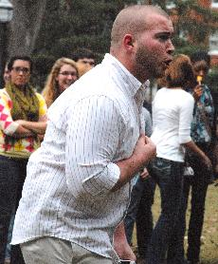

“YE ARE THE SUGAR OF THE EARTH”
Georgia Tech, November 19, 2009
I met other preachers on campus from SOPA, http://www.soapasn.com, (Southeast Open Air Preachers’ Association), Dick Christiansen, Zach Baxter and another brother. We had a permit from 11-2. The problem was that the designated free speech amphitheater is off the main flow of traffic. One must really project his voice to be heard as students are passing.
While waiting for the other brothers to arrive, I started preaching at 11 even though there was not that much of a flow of pedestrians. After preaching for about 10 minutes, I heard another preacher with amplification speaking in the fountain area. I walked over to check this out. One in this small group introduced himself. The pastor of the group is a former Maranatha pastor with whom I had fellowshipped in past years. Evidently, since this group is a student organization, they are able to preach at the fountain where there is more traffic.
Meanwhile, the SOAPA brothers had arrived and started preaching in the amphitheater, so I returned to the area to preach with them. We each took turns preaching. But we were only able to draw a few students over to our area. I conversed for a long time with a man who objected to my staff crucifix as an idol. I asked, “Do you consider a manger scene with the baby Jesus an idol?”
Somehow that was different to him. He claimed people do not worship Jesus in the manger. I explained that I do not worship my staff crucifix. It is a visual aid. He complained that we were bringing politics into our preaching. I explained that true religion influences every aspect of life. He turned out to be a socialist; but he refused to admit it.
When I was preaching, a man objected to my methods. He said his father was converted through a campus preacher, who turned out to be Tom Short. I explained that Tom was a friend of mine; and I have preached with him numerous times. I told the objector that I have heard Tom condemned as being judgmental and unloving and unbalanced. He blamed other campus preachers for Tom getting that label. He thought people were mistakenly associating Tom with the judgmental preachers.
Dick C. reproved the young man and the campus Christian groups for becoming the sugar of the earth instead of the salt of the earth. They want to be sweeter than Jesus. He said some are not even real sugar; but they are artificial sweetener.
Although we did not get much attention today, I considered it a profitable day to meet these brothers from SOAPA. Dick gave me one of his sandwich board signs which I had admired. It is in color with pictures and cartoon characters representing sins which plague students. It should be an effective attention getter. Dick is an effective and bold preacher with a good strong voice. I have heard a lot about him in recent years. He is a brother-in-law of John Duncan. Dick invited me to the next SOAPA conference.
A DAY OF VISITATION
University of Tennessee, Chattanooga, November 20, 2009
I took my stand outside the Student Union. I wore my new colorful sandwich board which quickly got the attention of a crowd of 150. However, within 15 minutes two policemen and Dean of Students, James Hicks, told me that I had to register with the Dean’s office. The Dean went inside to get the forms. The police insisted that I move away from the crowd off to the side until the paper work was done. Within 15 minutes the Dean was back; and I filled out the necessary papers.
The crowd built up again to around 75. The students were very excited with virtually all claiming to be Christians. Jake, who was a clean cut young man with reasonable questions, made clear that he was not a Christian. However, he said, “The Bible does teach that Christians are to proclaim the Word. You Christians are not doing that. You are the hypocrites not the preacher.” Jake had a lot of good questions and said that he would like to have a formal debate the next time I returned to campus.
There was a black Christian, Jamal, who spoke with some authority. His skin color is relevant because students tend to hush if an articulate black man speaks. He said, “The preacher has accomplished what he intended; he has your attention. You are listening and you will be talking about this later.” When I stopped at 3 PM, Jamal walked with me off campus and commended me for my witness.
The two policemen were hanging around most of the afternoon. At 2 PM the very overweight policeman told me I needed to stop since the crowd had enclosed me. I had already exhorted the crowd to give me some space and walked out of the circle. I told the policeman that if he thought there was some sort of threat from the crowd, he needed to exert his authority and tell the students to give me some space. I asked him if he was afraid of the students. When he realized that I was not going to leave, he did speak to the crowd and the people backed off. Shortly after, the police left. Which was good; they were not much help.
Several students wanted me to put away my sign about 2:15. I did so which had a calming effect upon the crowd. The sign had already accomplished its purpose and I wanted to speak on other topics then the sins listed on the sign.
It was a lively day. It was a day of visitation for students.

